

2023 SPANISH WINE, GOURMET CUISINE AND CULTURAL EXPERIENCE

SATURDAY, SEPTEMBER 2nd – MONDAY SEPTEMBER 18th

WITH

HOWARD FRIEDMAN – SPANISH WINE IMPORTER

4O YEARS OF WINE EXPERIENCE

Join me for a unique and extraordinary 14 daytour through Spain’s, most fabled countryside beginning in Galicia, Asturias; and Cantabria with wine tastings with the producers of at some of Spain’s most extraordinary *bodegas* in Rias Baixas, Ribeiro, Bierzo, Txakoli, Rioja , Ribera Del Duero; and Rueda. We will be dining on incomparable regional cuisine in two Michelin starred restaurant, and stopping for guided tours of the cathedral in Santiago de Compostela and the Guggenheim Museum in Bilbao. Our journey will draw to a close with time to enjoy the beauty of Madrid at one of the world’s finest hotels.

For 10 years,I think that I have been able to capture the most extraordinary experiences, the most incredible winery visits, and the most wonderful dining experiences imaginable, but each time I go, I find that, indeed, one can go home again! Always new things to see, exquisite meals to enjoy, and extraordinary wines to savor with fellow travelers.

Having the tour start in Santiago de Compostela has provided new opportunities to more deeply explore Galicia. Visiting with Casar de Burbia inBierzo adds a perfect glimpse of a small winery passionately producing a very small quantity of superb wines. Lunching in a 400 year old inn with Señor Do Campo at his winery in Ribeiro and tasting his exquisite white wine makes for both a great learning experience and an enchanting home-cooked meal. Traveling on to a chartered boat ride to the mussel grounds in the estuary of O Grove has proven to be a delicious prelude to one of the most extraordinary lunches I have ever had at a tiny, one Michelin star restaurant in Cambados.

During our stay in the Basque Region, we will enjoy a guided tour of the Guggenheim Museum, learn Basque cooking techniques at a tapas preparation class in San Sebastian, and visit BodegaKatxiña, a Txakoli winery of very high quality with vineyards along the banks of the river Oria. For those who know only a little about Spanish wines and for those who wish to visit the cellars of world renowned wineries, you will find that the learning experience is extraordinary! We will visit the vineyards, taste in the cellars and learn to appreciate the wide variety of flavors one finds in both red and white Spanish wines. All of these experiences amid the lush countryside and storied history of the land and its people.

It is much more than a time to take pictures and walk through quaint towns. It is a tour where you will be invited into a world of very special people who have created extraordinary wines. You will experience Spanish cuisine at its freshest and in its most amazing settings. And you will visit some of the world’s most astounding cathedrals and exquisite galleries. There will also be time for quiet walks on your own; dining experiences to savor by yourselves – a rich tapestry of encounters in every village and large city. Touring on your own at your own pace with suggestions from our Spanish guide and myself will help you get the most from your experience in a very personal way.a guided tour of the cathedral at Santiago de Compostela;

All of the last tours were a fantastic success for many reasons: the quality of the wineries that were visited; the Paradors and 4 & 5 star level of hotel accommodations; the wealth of information that was provided about Spain’s fascinating culture; and the superb cuisine and wine tasting experiences that are included in the tour price; and finally the smallness of the group and the personal attention given to assuring that each guest was highly pleased with their experience.

Previous tours have all included a lovely day in San Sebastian in the Basque country, where we will have a gourmet cooking lesson with a Basque Chef; but this year’s itinerary will make your visit to Spain even more special:

* On our way to Bilbao we will stop in Asturias for a tour and tasting at one of the finest cider producers in Spain.
* We will be learning the art of Tapas (Pintxos in Basque) preparation at a modern styled, highly rated, small plates restaurant in San Sebastian with lunch afterwards.
* A wonderful addition to our experiences is a chartered boat ride in a Galician estuary, “*ria”* in Spanish,for a visit to a floating barge called a “*batea”* from which mussels, oysters and “*vieras”* (scallops) are harvested. Afterwards we will have lunch at YayoDaporta in Cambados whose chef was the youngest chef to win a Michelin star and was also featured on Spain’s version of *Top Chef.*
* We will travel through the picturesque valley of the river Sil to Carracedelo in Bierzo where we will enjoy an alfresco lunch and tasting of the wines fromCasar de Burbia and after visiting their extraordinary, hillside vineyards along “The Way of the Cross”. These wines have received notable reviews from *The Wine Advocate; The Wine Spectator* and the prestigious*Penin Guide of Spain.*
* Bodegas Lopez de Heredia ViñaTondoniaand Proeliohave been added in Rioja. There you will tour their amazing cellars and barrel making facility and taste a wonderful array of their wines. At Proelio you will see how modern wine making philosophy differs from that of a very old family winery. At Javier Sanz, in Rueda, their incredibly old Verdejo vines and the newly resurrected Malcorta grape clone will be discussed and tasted. We will then enjoy a tapas lunch at the winery.
* In past years we have only had 2 nights in Madrid. Since 2019, an extra night in Madrid has been added so that there are now 3 nights and 2 full days as part of the tour. We will be staying at the spectacular Wellington Hotel in the exclusive Salamanca shopping district; close to the Prado, Reina Sofia and ThyssenBornemisza museums. The Madrid Metro, only a few steps away, will take you anywhere in Madrid you wish to go.
* On the final leg of our journey, it was sometimes the case that we arrived too early in the day for all of the rooms to be ready for us at our hotel in Madrid. I have added a short stop for lunch in Segovia as we travel south from La Seca in Rueda to preclude that happening. In this lovely city you will be able to see a 2000 year old Roman aqueduct that is still in use today.

THE TOUR IS DESIGNED FOR 20-24 PEOPLE

SEPTEMBER 2nd(Saturday) – Depart USA

SEPTEMBER 3rd(Sunday) - Arrive Santiago de Compostela. Transfer to Hotel NH Collection will be arranged for those who arrive in Santiago on the mid-day flight from Madrid.The rest of the day is at leisure.

OVERNIGHT HOTEL NH COLLECTION, SANTIAGO DE COMPOSTELA

LUNCH AND DINNER ON YOUR OWN

SEPTEMBER 4th (Monday) after breakfast, we willvisit the cathedral of Santiago de Compostela that has been the final destination for travelers on “The Way of the Cross” for centuries. It is without doubt breathtaking in its size, its architecture and glorious artwork. Your ticket and guided tour are included. There will be plenty of time for lunch before we depart for O Rosal and a tasting and tour at Altos de Torona, a truly exceptional producer of the Albariño, Paloma de Plata. We will taste a selection of their wines at their hilltop vineyard pavilion and enjoy a wonderful array of tapas. Later we will journey to the Parador of Baiona where we will enjoy a cocktail hour and wonderful dinner together. The Paradorlocated on its own peninsula is just a short walk from town and is one of the finest in all of Spain.

LUNCH ON YOUR OWN – WINE AT COCKTAIL HOUR AND DINNER ARE INCLUDED

OVERNIGHT THE PARADOR IN BAIONA

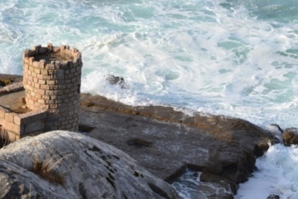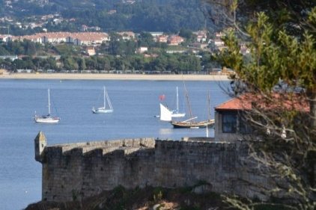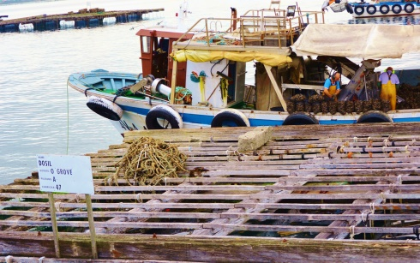

***Views from the Parador in Baiona “Bateas” in O Grove***

SEPTEMBER 5th(Tuesday) – After breakfast we have a short ride through the lovely countryside around the Galician estuaries to O Grove. A chartered boat will then take us for a visit to one of the *bateas* (barges) anchored in the river. You won’t believe the size of the freshly harvested mussels that we will have as an appetizer. Upon returning to the dock, we will drive to Restaurant YayoDaporta, a Michelin starred restaurant in Cambados, for a sumptuous multi-course lunch paired with the sommelier’s choice of regional wines.Yayo’s sister, Esther, will lead us in a tasting of wines prior to lunch.

After lunch we will return to the Parador. Later in the afternoon you may want to take a walk into town where you will find some lovely shops and fine seaside dining if you’re still hungry!

MICHELIN STARRED LUNCH WITH WINE PAIRINGS INCLUDED

DINNER ON YOUR OWN - ACCOMMODATIONS AT THE PARADOR IN BAIONA

SEPTEMBER 6th (Wednesday) After breakfast we will depart for Leon, but along the way we will stop for a winery tour, tasting and delicious lunch at Bodegas Do Campo in Ribadavia.

During your tour, you will see some exquisite architecture, beautiful landscapes and fine art. You will come away with a deep regard for Spain’s culture and an in-depth knowledge of the wines of Northern Spain, but the visit to Bodegas DoCampo, I think, will be one of your most memorable experiences. The Docampo family has updated a 400 year old farmhouse across from the winery, and it is here that we will enjoy our tasting and lunch.

Depending on the weather, you may have the experience of seeing the white grapes Godello, Treixadura, and Torontes being sorted and gently sent along their way to becoming wine.

The growing region here is Ribeiro and the delicate flavors of these wonderful grapes are kept fresh and bright through cold fermentation and stainless steel finishing. The winery also makes a delightfully soft, vibrantly fruity red wine that also is finished in stainless steel.

Lunch will include some very special dishes for which Galicia is most famous and the table will overflow with wonderful aromas and sumptuous food and wine.Scenes below from our lunch and winery visit to Bodegas Do Campo

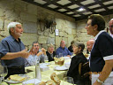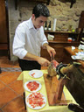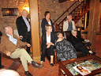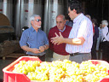

After lunch the road will take us through some of Spain’s most glorious scenery as we travel through the wine growing region of Ribera Sacra finishing in the D.O. of Bierzo

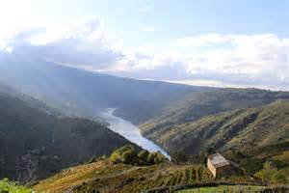[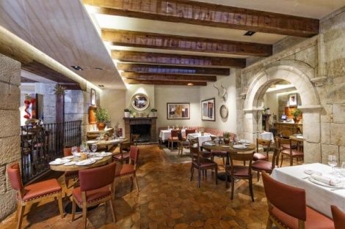](https://www.booking.com/hotel/es/condeluna.html?aid=1636199)

***The valley of the River Sil Conde de Luna Hotel, Leon***

We will be staying at the wonderful Conde de Luna in the heart of Leon and close to the cathedral.

WINE TASTING AND LUNCH ARE INCLUDED - DINNER ON YOUR OWN

ACCOMODATIONS AT THE CONDE DE LUNA, LEON

SEPTEMBER 7nth– (Thursday) Today we will enjoy a tasting and vineyard visit at Casar de Burbiain Carracedelo, Bierzo. The Menciaand Godellowines made here are some of the best in the entire region because the vineyards from which they come were so meticulously chosen by Isidro Bello’s grandfather. Some of the root stock of these vines is over 100 years old. There is great power in them and even the Penin Guide which is Spain’s most prestigious wine publication has given them extremely high praise. The winery is small and “work a day” but the tractor ride to the vineyards will give you a unique perspective on why the quality is so high.

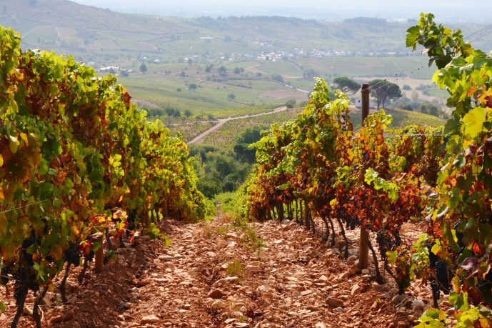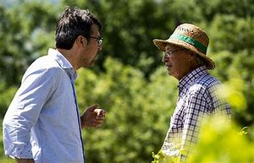

***Burbia’s hilltop vineyards of Mencia Isidro & his father discuss thevintage***

Our vineyard visit will be followed by an alfresco lunch at the winery along with a tasting of many of Isidro’s beautifully executed wines.

After lunch, an hour’s bus ride is just enough time for a light nap before we reach the wonderful city of Leon.

Once the center of a great kingdom, Leon is today a uniquely Spanish town with one of the most exquisite cathedrals in all of Spain.It’s astounding array of stained glass windows dates from the 13th century and soars to over 100 feet. The vibrant colors have survived 8 centuries! One of Gaudi’s earliest buildings is located here. After the cathedral visit, stroll through the city enjoying the tradition of the Spanish custom of the *paseo.*

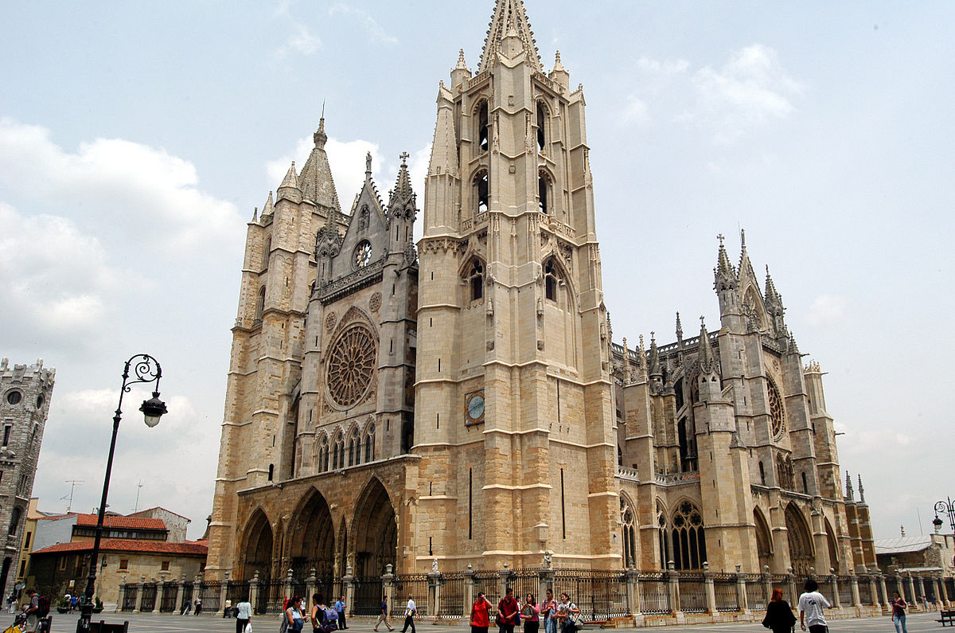

***The magnificent Leon cathedral and it’s 800 year old stained glass windows***

[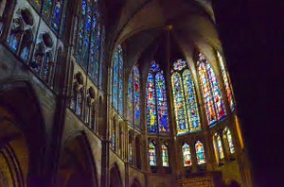](https://www.bing.com/images/search?view=detailV2&ccid=wqVMqjId&id=11829C35A56EC498AE187B7DBFA5DA3F837E570B&thid=OIP.wqVMqjIdn0hVacuJu0oJxwEsDG&q=leon+spain+images&simid=608048464660202633&selectedIndex=57&qpvt=leon+spain+images)

WINE TASTING AND LUNCH ARE INCLUDED - DINNER ON YOUR OWN

ACCOMMODATIONS AT THE CONDE DE LUNA HOTEL, LEON

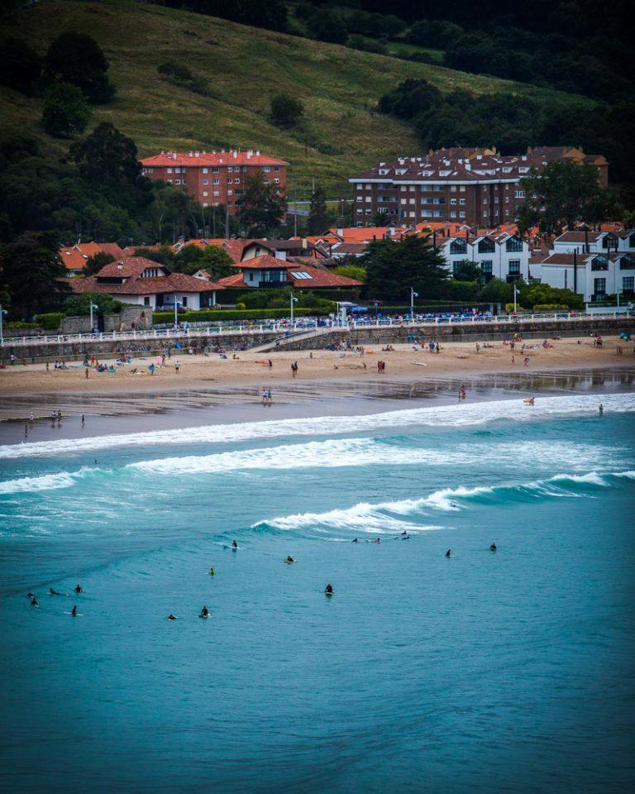

SEPTEMBER 8th – (Friday) As we thought about the length of the drive we came upon the idea of an interim stop in Asturias: Spain’s province with world famous cider. We will be stopping in the lovely seaside town of Ribadasella at one of their famous cider cafes for a unique cider tasting and a bit of pintxos before traveling on to Santillana del Mar, a lovely, historic village whose name derives from the Romanesque style Santa Juliana Collegiate Church around which the village grew. It’s quaint cobblestone streets lined with delightful cafes and artisan shops are a delight.

There will be time for lunch so make sure you enjoy some wonderful seafood at our stop here in Cantabria before traveling further along Spain’s north coast to our final destination of Bilbao.

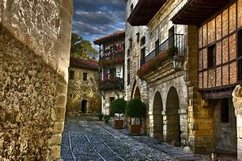

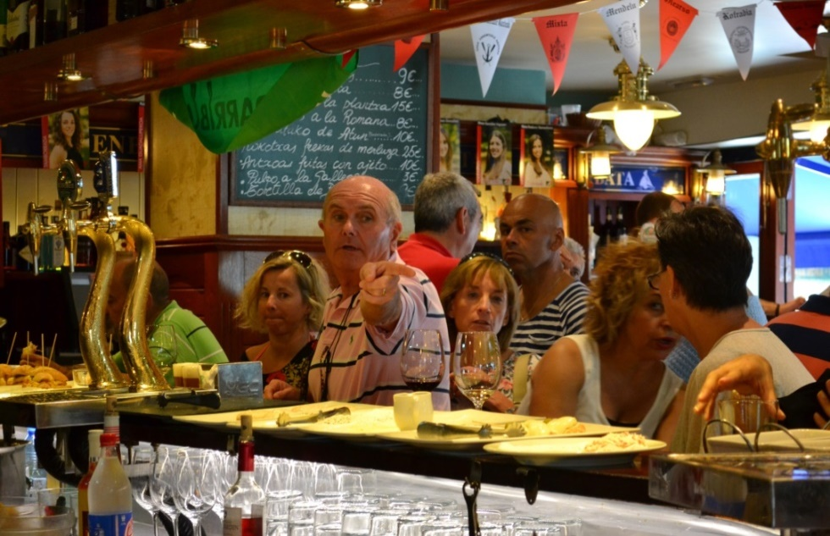

***WELCOME TO THE BASQUE COUNTRY***

The quality and style of Spanish kitchens where young chefs prepare ground breaking menus is extraordinary, and in Bilbao and San Sebastian you will find some of the finest cuisine in the country. Dining on your own in this city can include some of the most exquisitely prepared dishes in Michelin “starred” restaurants that you will ever experience or simple “pintxos” at a more moderate price. The restaurant in the Guggenheim itself, Nerua, is a one star Michelin restaurant. There are 3 Michelin starred restaurants in or nearby that are in the world’s top 10.

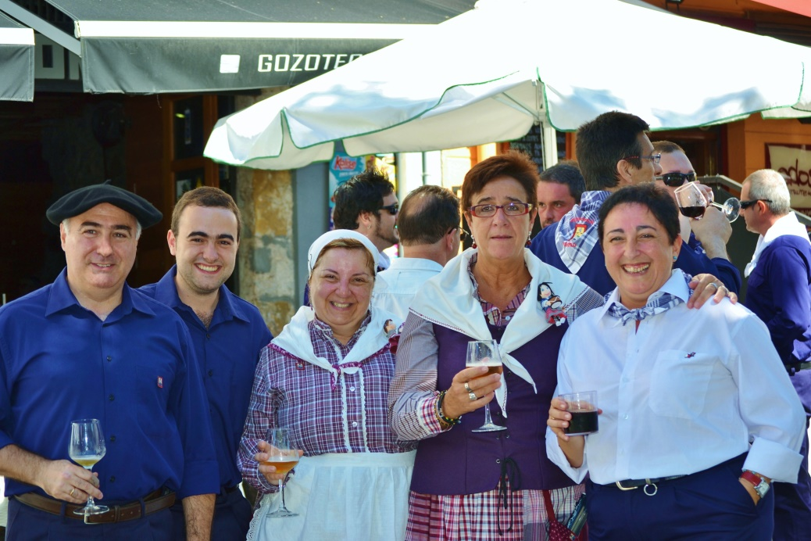

***Bermeo, a short bus ride from Bilbao - A traditional Basque town***

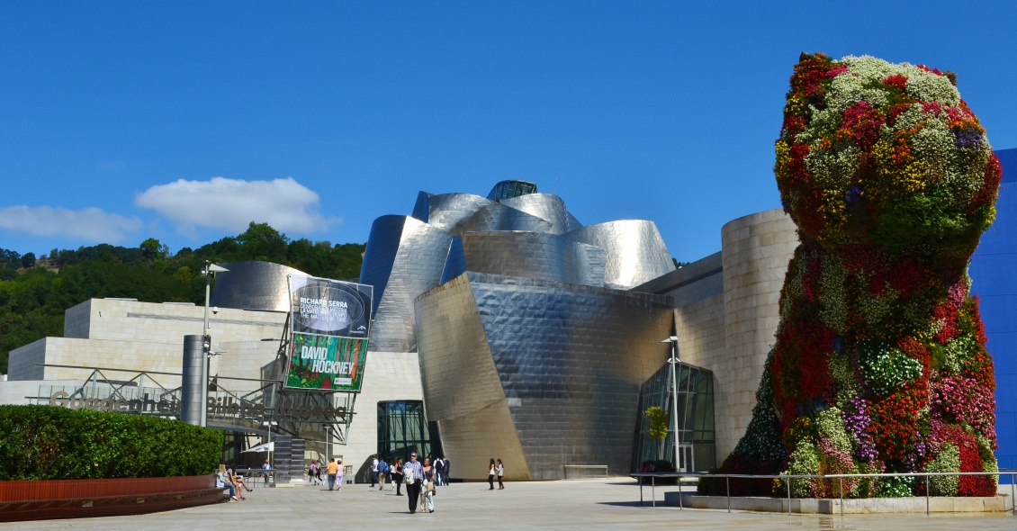

***The main entrance to the Museum with the iconic Puppy by Jeff Koons***

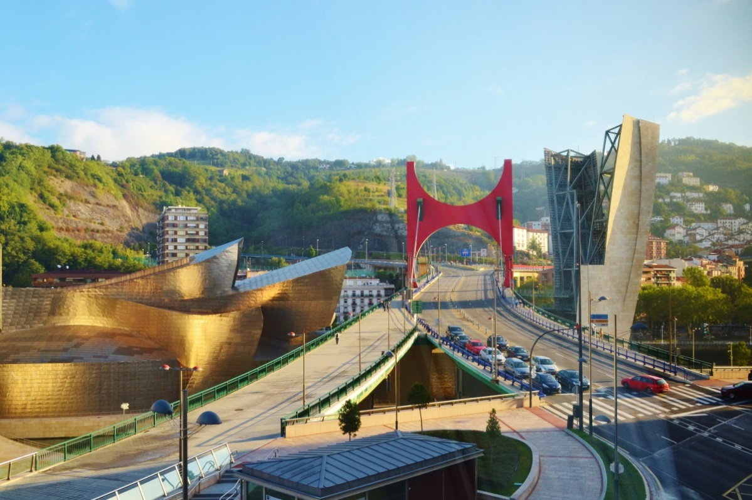

***The Guggenheim Museum and it’s companion bridge structure***

Instantly hailed as the most important structure of its time and “…a magnificent example of the most ground breaking architecture to have come out of the 20th Century. It is an innovatively designed architectural landmark that creates a seductive backdrop for the exhibition of modern art

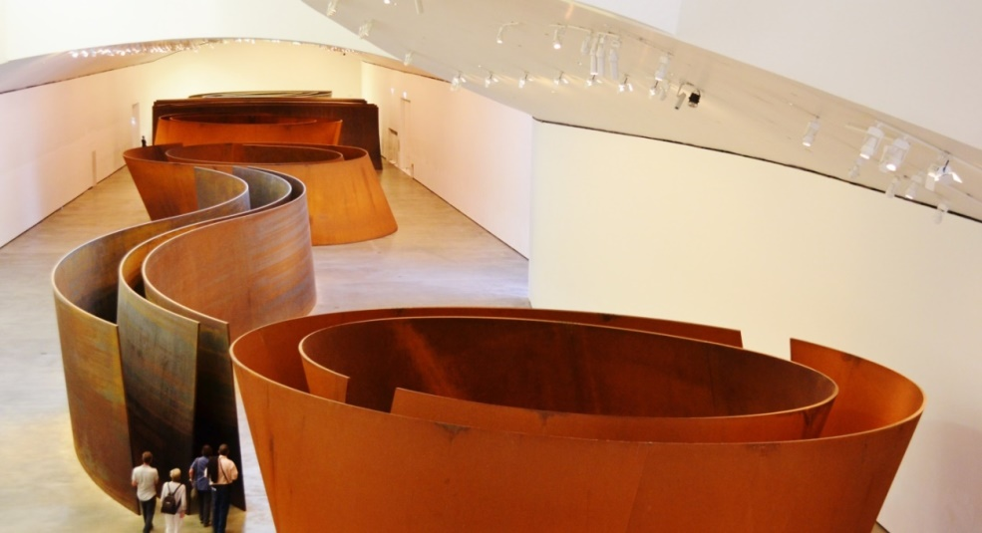

***Richard Sara’s incredible “The Matter of Time” at the Guggenheim***

[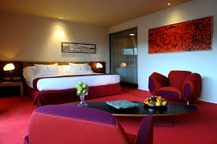](https://www.google.com/imgres?imgurl=http://www.hoteles-silken.com/content/imgsxml/es/galerias/panel_rooms_list/6/hoteles-grandomine-habitaciones-guggenheim-suite.jpg&imgrefurl=http://de-gustibus-non-est-disputandum.blogspot.com/2015/06/bilbao-el-guggen.html&h=850&w=1278&tbnid=EcoLPGq10aOg4M:&docid=3z6WVlpEZRt3NM&ei=nCriVpWkO8OwjgTe8rbAAg&tbm=isch&ved=0ahUKEwiV4ua1yLfLAhVDmIMKHV65DSg4ZBAzCDcoNDA0)

***Spacious room at the Silken Gran Domine hotel in Bilbao***

At the Silken Gran Domine, one of the finest hotels in the Basque country, you will enjoy luxuriously modern accommodations directly across the street from the Guggenheim and just a short walk along the river to many fine shops and superb restaurants in the old town. It is ranked #1 on Trip Advisor’s hotels in Bilbao.

LUNCH AND DINNER ON YOUR OWN - ACCOMMODATIONS AT THE SILKEN GRAN DOMINE IN BILBAO

SEPTEMBER 9th (Saturday) – After breakfast this morning, we will enjoy a guided tour of the Guggenheim. As an addition to this year’s tour, we will be including lunch at Nerua, a Michelin starred restaurant in the Guggenheim itself.

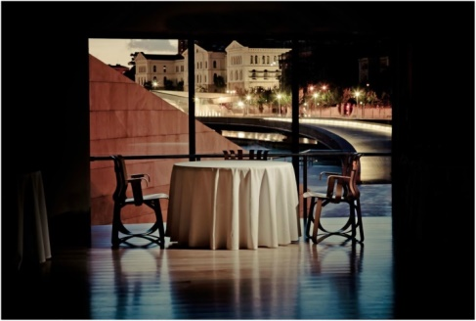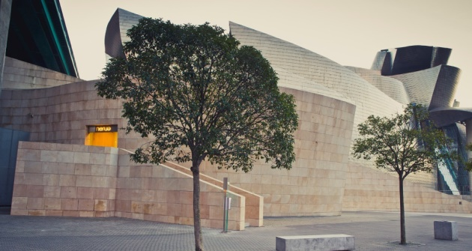

More details about that opportunity will follow.

MICHELIN STARED LUNCH AT NERUA-DINNER ON YOUR OWN –

ACCOMMODATIONS AT THE SILKEN GRAN DOMINE

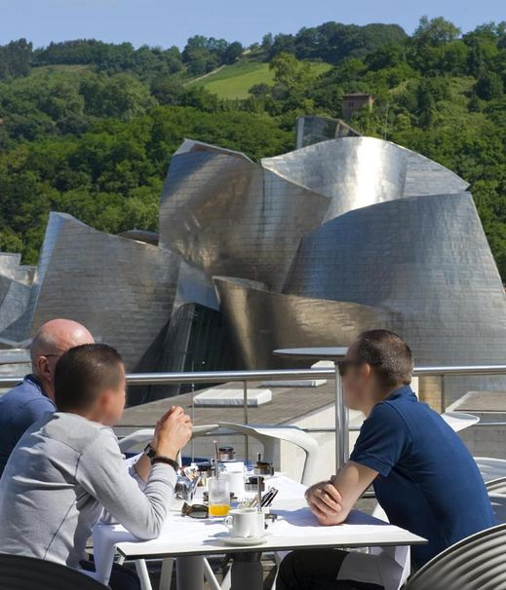

***Silken Gran Domine’s roof top breakfast setting***

We will have some wonderful breakfasts during our tour but, the setting – on one of the top floors of the hotel – is gorgeous!

SEPTEMBER 10th (Sunday) – After breakfast you will be able to don your “chef’s hat” as we travel to MIMO School in the Maria Cristina Hotel in San Sebastian for a Tapas preparation class which will include a delicious lunch at the conclusion of the class.

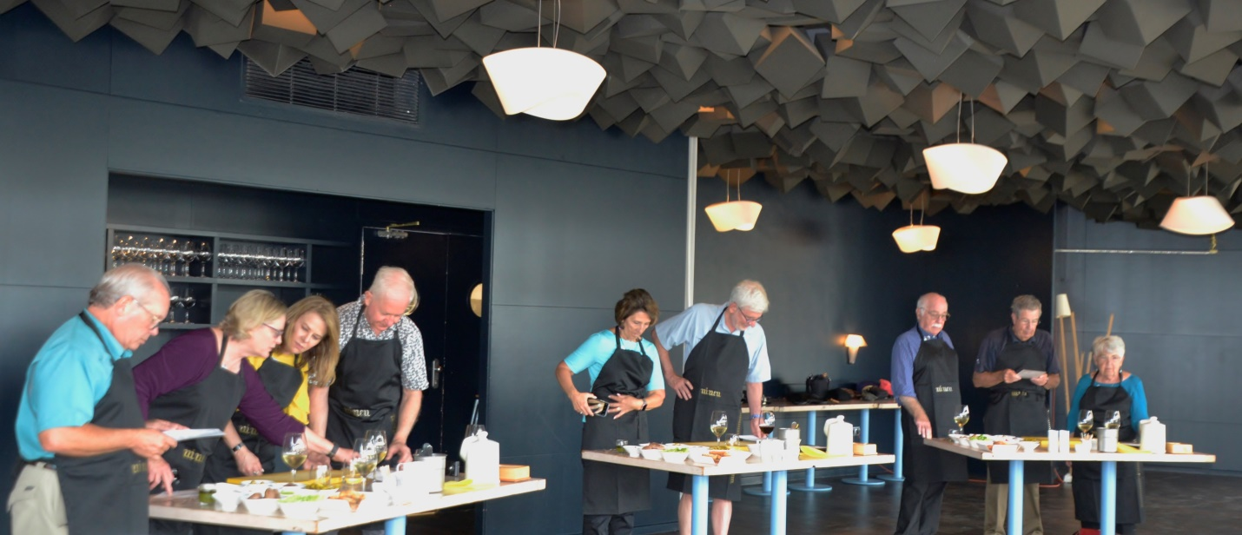

After lunch there will be plenty of time to stroll through San Sebastian before we return to Bilabao and our hotel

LUNCH IS INCLUDED DINNER ON YOUR OWN –

ACCOMMODATIONS AT THE SILKEN GRAN DOMINE

SEPTEMBER 11th (Monday) -

A short drive from Bilbao will bring us to Bodega Katxiña in the Getariaka sub-region of Txakoli. This amazing, south facing winery at the center of 8 hectares of vineyards is set on a hillside leading down to the Oria River. It was started only a few years ago and its wines have already been recognized as some of the best produced in the region.

The only grape grown here is HondarrabiZuri a white grape that was brought to this region from the northeast of Europe during the middle-ages. Other producers in this region use other grapes in a blend to give nuances to the wine, but Katxiña uses only this one grape. The secret to the wonderfully well balanced wine comes from the different vineyard styles and hillside locations that add subtle character that makes this wine so enjoyable. Only one wine is produced here and it is 100% HondarrabiZuri.

Like many other wineries in this region, there is a restaurant at the winery with upscale Basque cooking. **At Katxiña, their restaurant was named to the list of “The Best Luxury Grill Restaurants in the World”!!! We will enjoy a superb multi course lunch after our visit to the winery.**

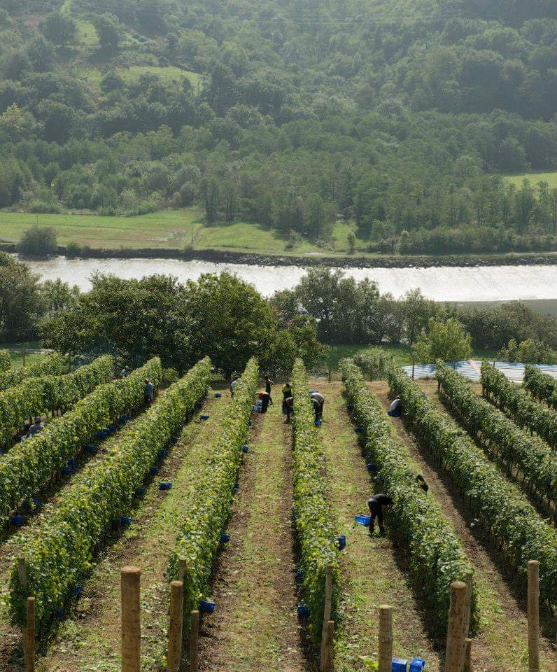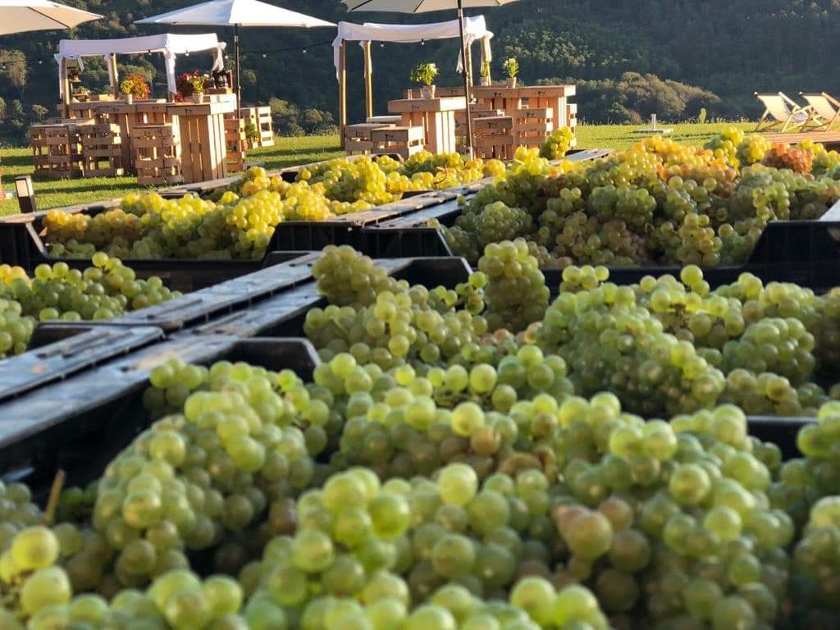***Hillside vineyards at Katxiña Harvested Hondarrabi Zuri grapes***

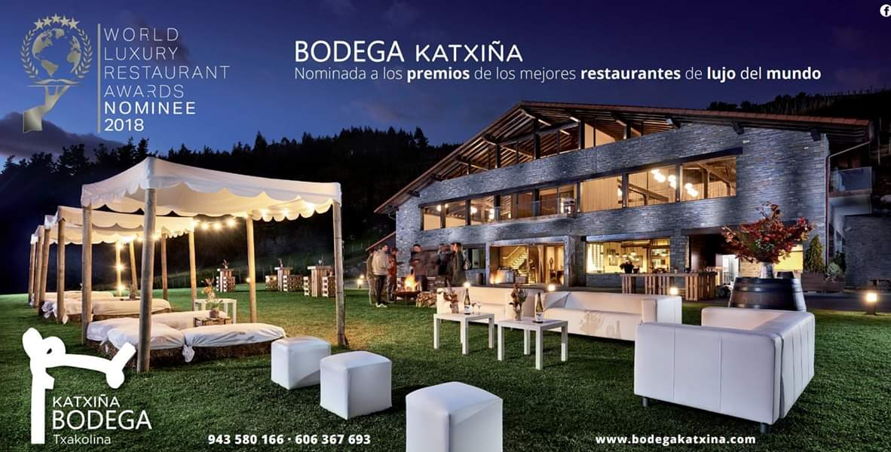

***A lovely setting for winery functions and for our tasting and exquisite lunch.***

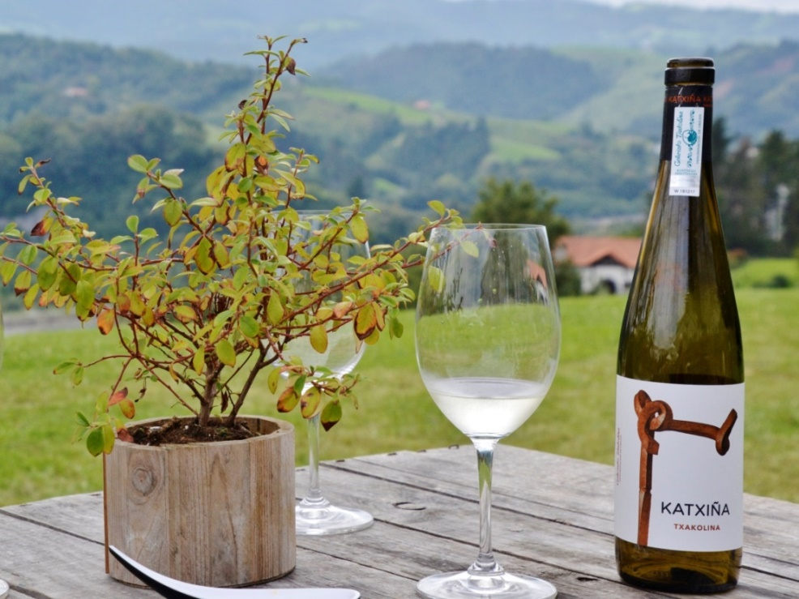

WINE TASTING INCLUDED – LUNCH AT THE WORLD FAMOUS KATXIÑA GRILL

DINNER ON YOUR OWN

ACCOMMODATIONS AT THE HOTEL MERCURE CARLTON LA RIOJA IN LOGROÑO

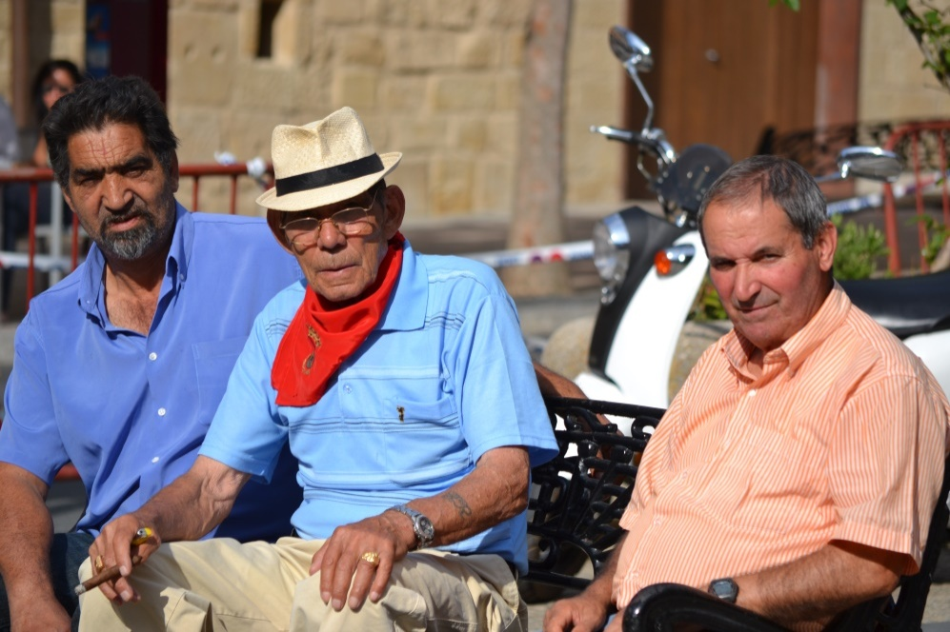

***WELCOME TO LA RIOJA***

SEPTEMBER 12th(Tuesday) – After breakfast we will have only a short ride to the world famous Bodega and vineyards of Lopez de Heredia ViñaTondoniain Haro where we will enjoy a tour of the winery, and wine tasting.

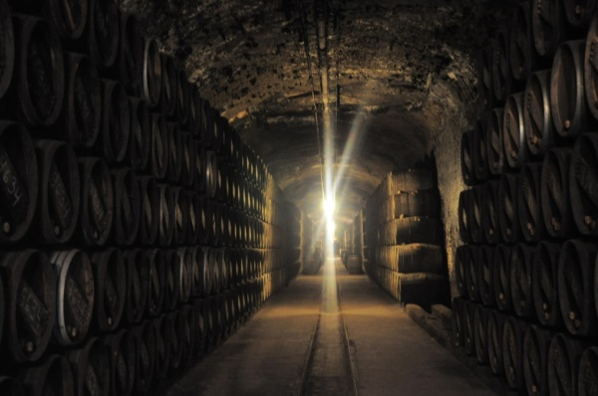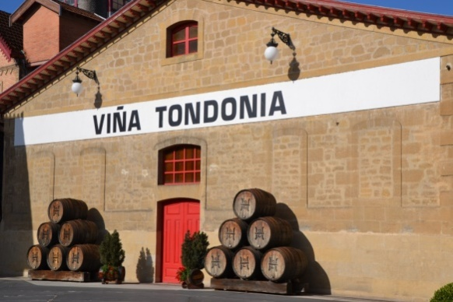

*Deep underground barrel aging cellars Welcome to Lopez de Heredia*

At Lopez de Heredia we hope you will learn a great deal not only about the winery and it’s fabulous wines but about making of Rioja wines of superior quality. Over 145 years of history have made the the Bodega and its wines world famous. You wil taste a selected group of gorgeous wines as well as take a guided tour of the many winery buildings

After our visit, we will travel to Nalda and a visit with Palacios Vinos de Finca, we will have the unique opportunity to taste wines from vines cultivated in the new and the old way and then taste the wines done in the same contrasting ways. As part of the portfolio of wines represented here, we will taste Proelio (Rioja), Nivarius (Rioja Blanco), and TRUS (Ribera del Duero).

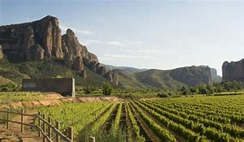

The wines of Bodegas Proelio follow three basic principles: The varieties we use to elaborate our wines; the use of our own vineyards at an altitude of almost 800 meters; and their north facing orientation. This is our way to guarantee the varietal character of the grape, its freshness and acidity. These 3 conditions also characterize our wines and sum up our philosophy and understanding of their elaboration. Nine different vineyard sites are the heart of what makes Proelio special. Each is dedicated to varieties which will benefit most from the differences in soil. Proelio’s wines are “grown” in the face of adversity. They are the result of the work and the effort required by high altitude vineyards. “That’s where our distinctive character lies.

There will be time to enjoy lunch and a stroll trough the lovely walled village of Laguardia before we head back to the hotel in Haro.

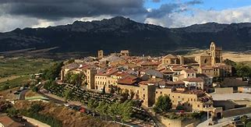

***The walled village of Laguardia in Rioja Alavesa***

WINE TASTING INCLUDED - LUNCH AND DINNER ON YOUR OWN

ACCOMMODATIONS AT THE HOTEL MERCURE CARLTON LA RIOJA IN LOGROÑO

SEPTEMBER 13th (Wednesday)After breakfast we will travel toBodegas Valduero for a tour of the cellars, a wine tasting and lunch. A multi-course gourmet lunch will be served with meticulously paired wines. These wines have often received 90 points or higher from Robert Parker, and your tasting and vineyard tour will be guided by Yolanda Viadero, the winemaker and daughter of the winery owner, and/or the export manager.

[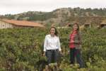](http://www.bodegasvalduero.com/images/slideflashnuevabodega/lasnegras3.jpg)[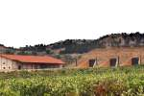](http://www.bodegasvalduero.com/images/slideflashnuevabodega/lasnegras1.jpg)[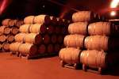](http://www.bodegasvalduero.com/en/images/slideflashtuneles/lasnegras6.jpg)

***CAROLINA AND YOLANDA AT THE VALDUERO WINERY***

In past years, our lunch at **Bodegas Valduero**was one of the highlights of the trip. The whole range of their wines were opened and paired with an incredible lunch served at the winery. The guests enjoyed the wines so much that they ordered several cases of wine which they purchased when they returned to the U.S. In fact, there is a very special barrel program that you will learn about. At an elevation of over 2800 feet, Burgos is situated at a crossroad along the Camino de Santiago, the historic “Way of the Cross”. The cathedral in Burgos was begun in 1226 and not finished until 1493! It has been declared a “World Heritage Site” by UNESCO and is one of the most extraordinary in all of Spain. In its treasure room can be found a 15th century monstrance that is said to be gilded with gold brought from the New World by Columbus. Here you will also find the tomb of El Cid, Spain’s greatest national hero.

[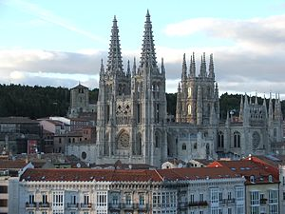](http://en.wikipedia.org/wiki/File:Catedral_de_Burgos_II.jpg)

We will stay at the magnificent Palacio de Burgos, a restored 16th century monastery. It’s elegantly appointed rooms are only a 2 minute walk from the historic center of the city.

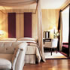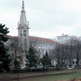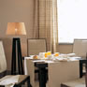

A WINE TASTING AND FABULOUS LUNCH PAIRED WITH VALDUERO WINES ARE INCLUDED - DINNER ON YOUR OWN

ACCOMMODATIONS AT THE NH COLLECTION PALACIO DE BURGOS

SEPTEMBER 14th (Thursday) After breakfast we will travel to Pedrosa de Duero for a tour of the fabulous cellars of Pago de losCapellanes and a tasting of their very special and highly rated wines from Ribera del Duero and now, some delicious Godello white wine from Valdeorras.

In the 14th century, a chaplainry existed in the village of Pedrosa de Duero just 1 mile away. The villagers donated small parcels of land to the chaplains for their work and,

over time, these holdings became quite large. About 500 years later these lands were given back to the village, but they retained the name “Land of the Chaplains”. The present owner, PacoRodero, purchased the lands from the village and built a magnificent winery using the finest equipment and the most perfect cooperage to make some of Ribera del Duero’s finest wines.

[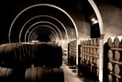](http://www.pagodeloscapellanes.com/Pago_de_los_Capellanes/LA_BODEGA_en_files/25_80_1.jpg)[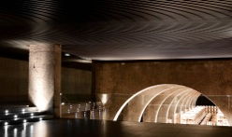](http://www.pagodeloscapellanes.com/Pago_de_los_Capellanes/LA_BODEGA_en_files/19_80_1.jpg)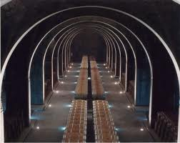

***THE CELLARS AT PAGO DE LOS CAPELLANES***

These wines have consistently received extraordinarily high praise from the world’s wine press and in the past have been among those wines on the Wine Spectator Magazine’s “Top 100” list. In 2012 and again in 2016 this winery was “Winery of the year” for *Wine & Spirits Magazine.* Afterwards we will return to Burgos where you will be free to enjoy more of the city’s charm.

Capellanes has only produced red wines for its entire history, but just recently a winery was purchased and vineyards developed to produce white wines called “O LUAR DO SIL” They are made with Godello grapes developed both in stainless steel and French oak barrels. You will enjoy these wines at the tasting in the winery.

We will then travel back to Burgos to enjoy the rest of the day on your own or take a fascinating visit to the cathedral where your entrance fees have already been paid.

WINE TASTING INCLUDED –LUNCH AND DINNER ON YOUR OWN

HOTEL NH-PALACIO DE LA MERCED, BURGOS

SEPTEMBER 15th (Friday)

Spanish red wines have dominated the country’s presence in the U.S. market for many years, but lately new winemaking techniques and resurrection of indigenous clones long absent from producer’s references have markedly changed that view of the Spanish wine industry. It is an interesting footnote to the production of white wine in the D.O. of Rueda that it was with the dedication of the director of Marques de Rascal and his work with a French Oenologist, Emile Reynaud that the production of high quality wine from Verdejo – Rueda’s principle grape – began.

At Bodega Javier Sanz, this dedication to the extraordinary quality of wine that could be produced in Rueda from modern viticulture practices is its mantra. Painstaking work in the vineyards to ensure the best quality grapes and the inclination to intervene as little as possible in the natural winemaking process have assured the production of Verdejo with the delicate, crisp gooseberry flavors for which it is famous.

[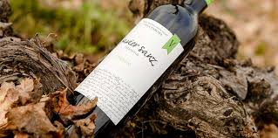](https://www.google.com/imgres?imgurl=https://www.bodeboca.com/sites/default/files/imagecache/thumbnail_bodega_landscape/bodega-javiersanz-4.jpg&imgrefurl=https://www.bodeboca.com/bodegas/javier-sanz-viticultor&docid=6vZosARvbY7qpM&tbnid=bV-iW7MvM1JOeM:&vet=10ahUKEwi49pH8u_fVAhUCOSYKHResCnQQMwhWKCcwJw..i&w=595&h=296&bih=932&biw=1920&q=bodegas%20javier%20sanz%20rueda%20images&ved=0ahUKEwi49pH8u_fVAhUCOSYKHResCnQQMwhWKCcwJw&iact=mrc&uact=8)[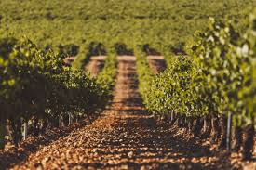](https://www.google.com/imgres?imgurl=https://www.solwines.es/wp-content/uploads/2017/05/javiersanz6.jpg&imgrefurl=https://www.solwines.es/2017/05/bodega-javier-sanz-d-rueda/&docid=gZe7VQlbUmtg8M&tbnid=XVeJal2zg-ILbM:&vet=10ahUKEwjmrdO3vPfVAhXD5yYKHdOUAloQMwhKKBswGw..i&w=1300&h=864&bih=932&biw=1920&q=bodegas%20javier%20sanz%20rueda%20images&ved=0ahUKEwjmrdO3vPfVAhXD5yYKHdOUAloQMwhKKBswGw&iact=mrc&uact=8)

Javier Sanz has dedicated his winery to the production of wines from pre-philloxera vines and the recovery of varieties that have almost become extinct. His Malcorta wines are the culmination of this effort and represent a style of Rueda white wine that, but for his interest would have disappeared.

A fabulous visit to the original, 19th century winery has been arranged with a tasting of the superb quality Rueda produced there. We will visit the vineyards which are the very special heritage of Javier Sanz’ wines and we will enjoy a tapas with our tasting at the winery.

After our visit we will travel on to Madrid. We will stop in Segovia on the way.

WINE TASTING WITH LIGHT TAPAS INCLUDED – LUNCH AND DINNER ON YOUR OWN

ACCOMMODATIONS AT THE WELLINGTON HOTEL MADRID

SEPTEMBER 16th (Saturday)

Free day in Madrid.

The Wellington is by any standard a remarkable hotel. This elegant 5 star hotel in the heart of the sophisticated Salamanca shopping area of Madrid exemplifies the ability to frame uniquely modern dining experiences with the highest of old world excellence of service and elegance of setting. Enjoy lunch, dinner, an evening cocktail or even a relaxing swim on the Wellington Terrace. The Kabuki Wellington offers the best sushi in Madrid and is the proud recipient of a Michelin star. The Goizeko Wellington is the result of “a culinary union between Jose Santos and Chef Abel Maretlloti and serves innovative and seasonal Basque Haute Cuisine.”

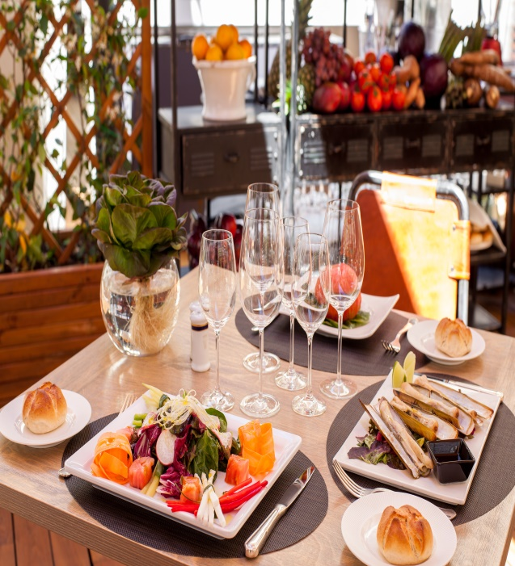

LUNCH AND DINNER ON YOUR OWN

ACCOMODATIONS AT THE WELLINGTON HOTEL, MADRID

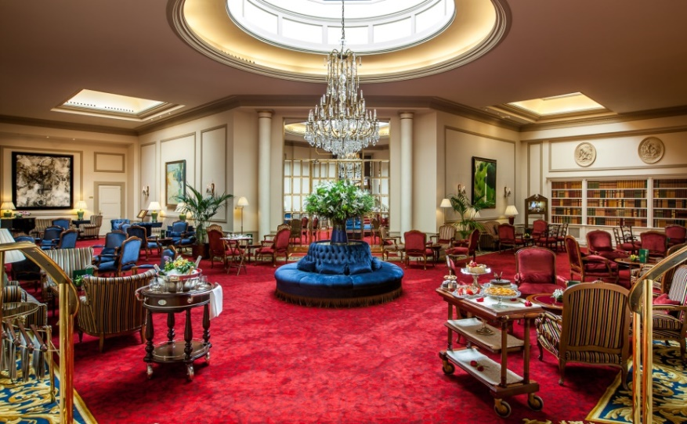

SEPTEMBER 17th(Sunday) Free day in Madrid to enjoy the museums, shop, visit the Royal Palace, throw caution to the wind and take a Segway tour, or watch Flamenco dancing after a visit to the raucous Plaza Mayor. This evening a cocktail hour at the hotel is planned as a final group get-together with tapas

LUNCH DINNER ON YOUR OWN ACCOMMODATIONS AT THE WELLINGTON HOTEL

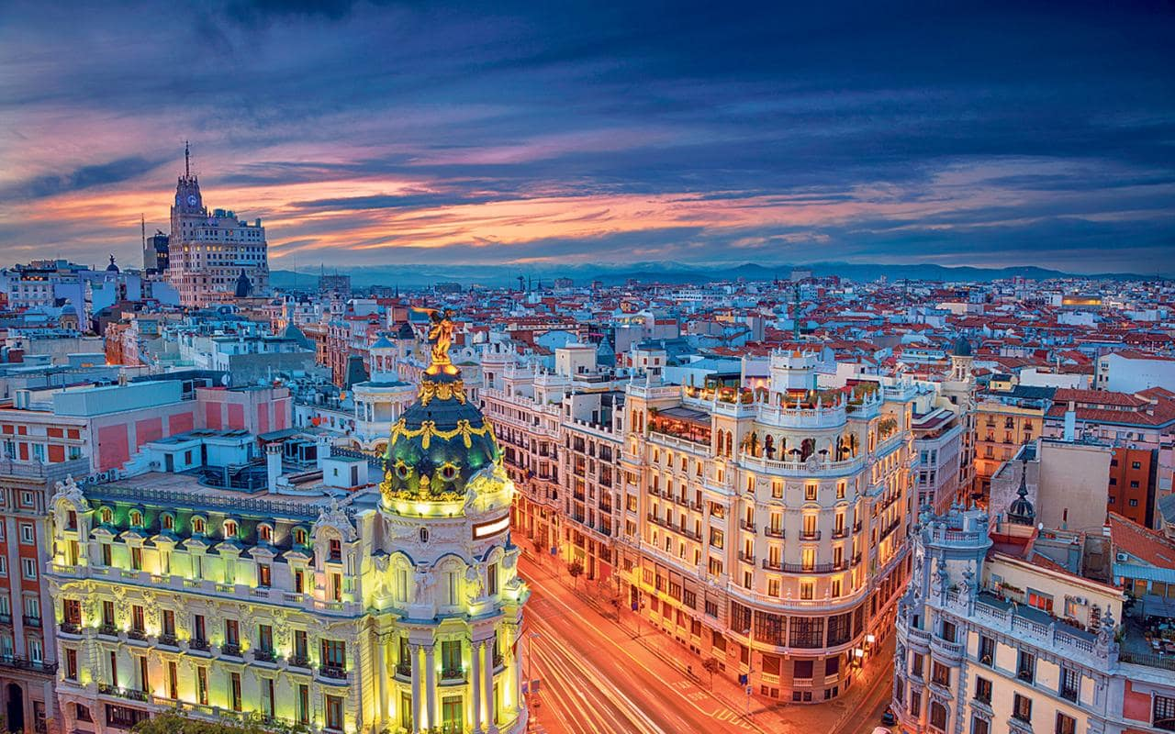

***A NIGHT VIEW OF THE GRAN VIA***

OCTOBER 1st (Monday) – After breakfast you will need to make arrangements for transfer to the airport for your return flight. Sun Bird Travel can assist you in making these arrangements.

**+++++++++++++++++++++++**

Merrill Dilley of Sun Bird Travel, Marcos Roel of Petrabax Tours, and I have worked long and hard to organize a truly memorable experience for you. Antonio Abastas, our Spanish guide, and I will work even harder during the tour to make certain that you will learn something about Spain and its heritage every day.

I tried to keep the price as low as possible while keeping the quality of the hotels at the highest level. At the end of the day, the difference between top quality hotel accommodations and those of lesser quality was very small, and I know from my own travel experiences that it is the little touches of elegance and style that will forever remain in your memory of the trip.

I truly hope you can join me, because the only thing I enjoy more than a glass of wine is sharing the experience with people who enjoy it just as much as I do.

LAND ONLY PRICE$6349 PER PERSON DOUBLE OCCUPANCY

SINGLE SUPPLEMENT:

A DEPOSIT OF $500 PER PERSON IS REQUIRED TO SECURE YOUR PLACE

SPACE IS EXTREMELY LIMITED AND RESERVATIONS WILL BE TAKEN ON A FIRST COME FIRST SERVED BASIS FOR 20-24 PEOPLE. DEPOSITS SHOULD BE RECEIVED BY JANUARY 31, 2022. FINAL PAYMENT DUE BY: $1995

**TRIP IS NON REFUNDABLE - THE PURCHACE OF TRAVEL INSURANCE IS HIGHLY RECOMMENDED**

PRICING IS BASED UPON THE CURRENT EXCHANGE RATE AND IS SUBJECT TO CHANGE UNTIL FINAL PAYMENTS ARE MADE. SEE THE WEBSITE AT [WWW.HOWARDSWINETOUR.WEBS.COM](http://WWW.HOWARDSWINETOUR.WEBS.COM) FOR A COMPLETE EXPLANATION OF TERMS AND CONDITIONS.

WHAT’S INCLUDED:

* Baggage handling throughout the trip
* Accommodations at all hotels with full breakfast daily
* Non-smoking rooms will be standard
* 1 dinner and 7 lunches (lunches to include fine wine pairings)
* Wine tastings at 8 different wineries
* Entry fees and guide’s fees for the Santiago de Compostela Cathedral, the cathedral in Burgos, and the Guggenheim Museum
* A large, deluxe air conditioned coach throughout the trip with plenty of room to spread out and relax during your rides
* Spanish tour guide fluent in English as well
* Specially prepared handouts for each guest to more fully explain the wines and the Spanish wine culture.

WHAT’S NOT INCLUDED:

* Travel insurance – Purchase within 10 days of deposit to assure full refund – Call Merrill at Sun Bird Travel for details
* Air fare
* If paying by credit card there is an additional charge of 3.5%
* Tips for the Spanish tour guide and bus driver

AS MUCH AS WE TRY TO ASSURE THAT ALL ARRANGEMENTS ARE SOLIDLY MADE BEFOREHAND, CHANGES BEYOND OUR CONTROL MAY OCCUR AT THE LAST MINUTE.

DUE TO SOME VINEYARD TERRAIN, STEPS, AND SOME UNEVEN, COBBLESTONE STREETS, THOSE WHO HAVE DIFFICULTY WALKING MAY NOT BE ABLE TO ENJOY ALL ASPECTS OF THIS TOUR.

**Checks should be made payable to: Sun Bird Travel Co. and mailed to:**

**Sun Bird Travel Co.,**

**1280 Grand Canal Drive, Naples, FL 34110**

**Contact for any questions you may have:**

**Howard Friedman (240) 401-9342 or** [**hfriedo@verizon.net**](mailto:hfriedo@verizon.net)

**Merrill Dilley, Sun Bird Travel (239)430-2000 or merrill.sunbird@gmail.com**